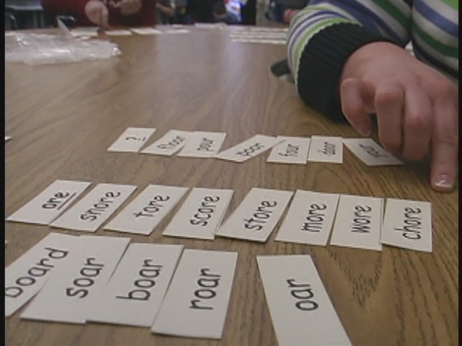
How to Do a Word Sort

- Take out your cards.
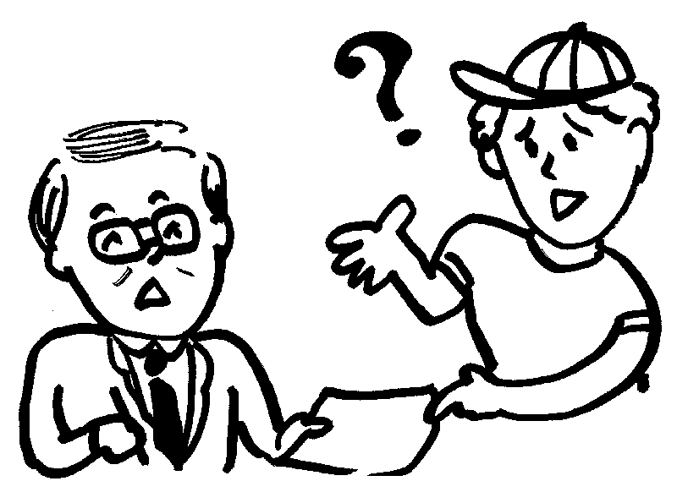

- Read all of your cards.

- Ask a question if you don't know a word.


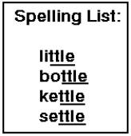
- Think about the sounds and spelling.

- Sort the words into columns.

- Read the words aloud to check.

- Ask the teacher to check.

- Write the words in your notebook in columns.

- Record your sort on your progress chart in your folder.

- Put your cards back in the envelope.

